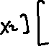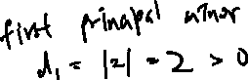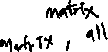

-

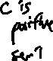

Why Are PSD Matrices Important in Machine Learning?

* positive semi-definite to ensure that it represents a valid inner product in some feature space.
* Many optimization problems require the use of positive semi-definite matrices, such as covariance matrices in portfolio optimization and regularization terms in regression.
* Covariance matrices, which are used to measure the correlation between different features in datasets, are always positive semi-definite.
* PCA relies on the eigenvalues and eigenvectors of a covariance matrix. The matrix being positive semi-definite ensures that the eigenvalues are non-negative.